**Semester 3: Practice Hands-on Exam**

**Topology:**

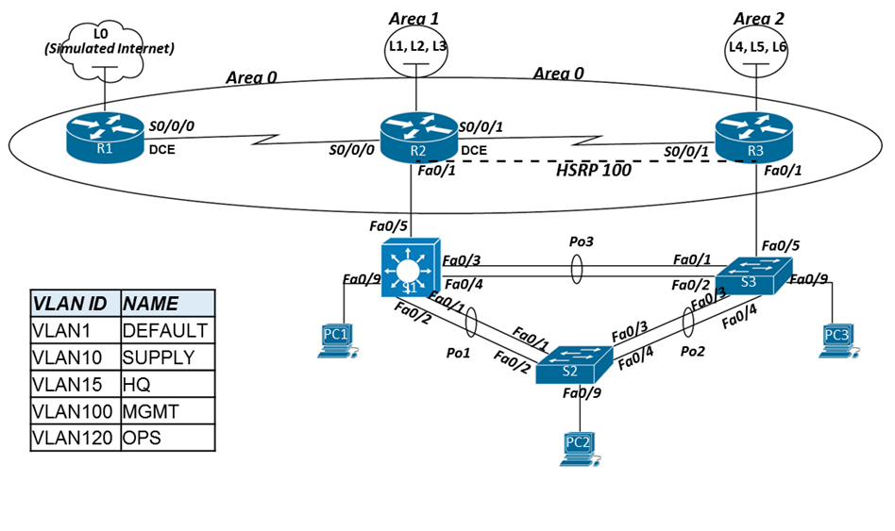**Addressing Table:**

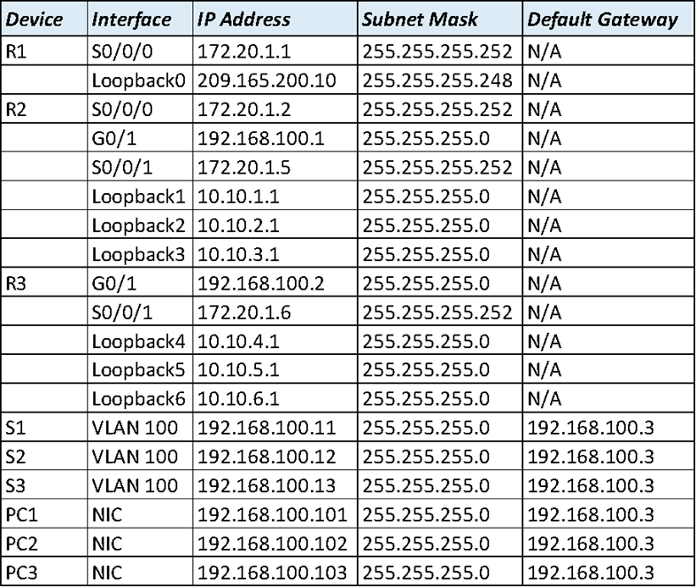

1. **Connect all devices per the topology diagram with the correct cables (straight-through/cross-over. Assume MDIX is not in use)**
2. **Configure basic security parameters for Router 1, 2 and 3.** 
   1. Configure the hostnames applicable (reference the topology)
   2. Disable DNS lookup
   3. Set the domain to CISCO-LAB.com
   4. Set an encrypted priv. exec. password to ciscoenpass
   5. Set the console password to ciscocon
   6. Set the vty telnet password to ciscovty
   7. Creating a MOTD banner stating “Unauthorized access is prohibited”
   8. Encrypt all clear text passwords
3. **Configure basic security parameters for S1, S2, and S3.** This includes:
   1. Configure the hostnames applicable (reference the topology)
   2. Disable DNS lookup
   3. Set the domain to CISCO-LAB.com
   4. Set an encrypted priv. exec. password to ciscoenpass
   5. Set the console password to ciscocon
   6. Set the vty telnet password to ciscovty
4. **Configure the Layer 3 interfaces for R1, R2 and R3**
   1. For R1, R2, and R3 set IPv4 addresses and subnet masks for the appropriate serial interfaces. Add descriptions for each active interface.
   2. Configure the LAN interfaces (FastEthernet or GigabitEthernet, depending on your router) for R2 and R3.
   3. Set the IPv4 addresses and subnet masks for all loopback interfaces.
   4. Ensure all appropriate interfaces have been activated.
5. **Configure the Layer 2 interfaces for S1, S2 and S3**
   1. Configure S1 VTP mode as server and S2/S3 VTP mode as client. Use the following information for VTP configurations:
      * + Domain: CISCO-LAB.com
        + Version: 2
        + Password: CISCOVTP
   2. Create the VLAN databases in S1, adding the VLANS listed in the VLAN key.
   3. Configure Rapid PVST+ on all switches.
   4. Configure the ports connecting switches to PC’s (shown in the topology) with access to “MGMT” VLAN (see VLAN key), configure Spanning-tree Portfast, and enable BPDU Guard for those ports.
   5. Configure **all** other unused ports as access ports with access to OPS VLAN (parking lot VLAN). Ensure all unused ports are shutdown.
   6. For VLAN100, configure S1 as the root primary and S2 as the root secondary.
   7. Configure an Etherchannel, with a group ID of 1, between S1 and S2 using PaGP. S1 will be actively negotiating to form a channel; S2 should only form a channel if requested.
   8. Configure an Etherchannel, with a group ID of 2, between S2 and S3 using LACP. S2 will be actively negotiating to form a channel; S3 should only form a channel if requested.
   9. Configure an Etherchannel, with a group ID of 3, between S1 and S3 that does NOT use DTP.
6. **Configure the Layer 3 interfaces for S1, S2 and S3**
   1. For each switch, configure appropriate SVI’s to allow for remote management (see addressing table).
   2. For each switch, assign the proper default gateway.
   3. On S1, configure interfaces Fa0/23 and Fa0/24 as layer 3 routed ports. Ports will not be used in this exercise, but may be used for future network expansion, so ensure interfaces are deactivated.
7. **Configure HSRP**
   1. Create HSRP group 100 on R2 and R3. They will share the virtual IP address of 192.168.100.3.
   2. Configure R2 as the primary router.
   3. Configure R2 to re-establish active role in case of a reboot.
8. **Configure Multi-area OSPFv2**
   1. Configure R1, R2 and R3 for OSPF using process ID 10.
   2. Set the router-id within OSPF to the following:
      * + R1: 1.1.1.1
        + R2: 2.2.2.2
        + R3: 3.3.3.3
   4. Advertise connected networks on all routers in OSPF in the appropriate area
   5. On R1, create a default route exiting the loopback towards the simulated Internet and propagate it to all routers via OSPF
   6. On all routers, configure all serial interfaces are in the backbone area
   7. On R2 and R3, all LAN interfaces are in Area 0 and set as passive interfaces
   8. On R2, all loopback interfaces area in Area 1
   9. On R3, all loopback interfaces area in Area 2
   10. Summarize Area 1 and Area 2 into the backbone area (they should appear to R1 as a single summary route representing the multiple loopback subnets)
   11. Change the default cost reference bandwidth to 1000 on **all routers** in OSPF
   12. showSet the metric cost for **all serial interfaces** to 7500 for all serial interfaces on all routers.
   13. Set the bandwidth of **all serial interfaces** to 128kbps on all routers.

**auto**

***Command References***

* What command displays all summarized output of the VLANs currently in the VLAN database and the ports associated with those VLANs?

* What command displays STP configurations (root bridge ID, participating ports, port roles, priority) for a specific VLAN?

* What command displays a consolidated output (port channel ID, protocol, participating ports) for all configured etherchannels?

* What command displays detailed information about all currently configured HSRP groups?

* What command can be used to verify that mutli-area OSPF is being used on the network?